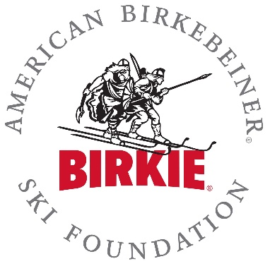
2018-2019 American Birkebeiner Ski Foundation (ABSF)
Skier Development Grant Program Application
Grant Eligibility and Reporting
- All groups awarded grants must submit a W9 prior to grant award.
- Awarded programs must complete a final report by April 1, 2019.
- ABSF should be recognized on publications and other printed material that is created using grant funds.
________________________________________________________________________
Application Procedures
- Application Deadline is Friday, September 14, 2018.
- Applications must be submitted in Microsoft Word format via email to john.oman@birkie.com.
- Document must be saved as (your organization name)18.doc or docx. (PLEASE SUBMIT ONE FILE)
- Provide all information in the order listed.
- Application should be limited to five (5) pages.
- Do not include any other materials with this application.
- Both successful and unsuccessful grant applicants will be notified via email by Wednesday, October 26, 2018.
________________________________________________________________________
Organization/Program Information
Name of Organization/Program:
Address:
City: State: ZIP:
Phone: Email:
Program Director:
Phone: Email:
Grant Contact Person:
Phone: Email:
List other Key Staff/Coaching Staff:
Is your organization a 501(c)(3)? *Note: this is not required to receive a grant.
Do you have a matching grant?
Are you applying for a Small grant or a Large grant? Please note there are different conditions for Large grants.
Grant Request Amount:
Page 1 of 2
Please respond to the following questions so the ABSF can better understand your program:

- What is the mission statement of your organization?

- What are the primary goals or objectives of your program?

- For youth programs: What youth ages does your program cover? How many youth skiers are currently involved?

- How long has the program been in place? If this is a new program, please indicate your expectations for your first year.

- What are the expected outcomes of your program?

- What are the demographics (geographic area, size, and other characteristics) of the population served by your program?

- What is the annual budget of your program? Please provide a copy of your budget or annual financial plan, if available. How else, specifically, do you plan to obtain funding for your program? Include names of other funding partners or sponsors.

- What specifically do you intend to use requested ABSF grant funds for?

- How do you involve your local community in your program?

- Does your program use a social media platform? If so, how could you use social media to enhance your partnership with the ABSF?

- How are your program participants currently involved in ABSF Events?

- If awarded an ABSF grant, how will you promote the mission of the Birkie lifestyle in your community and involve the Birkie in your program?

- Aside from cash funding, are there other ways the ABSF can assist your organization and programs?

Thank you very much for your interest in a Skier Development Grant from the American Birkebeiner Ski Foundation. Grants are awarded based on the collective decision made by our Skier Development Committee. We do have a limited budget for grants. However, we hope to fund as many worthy programs as possible each year.

